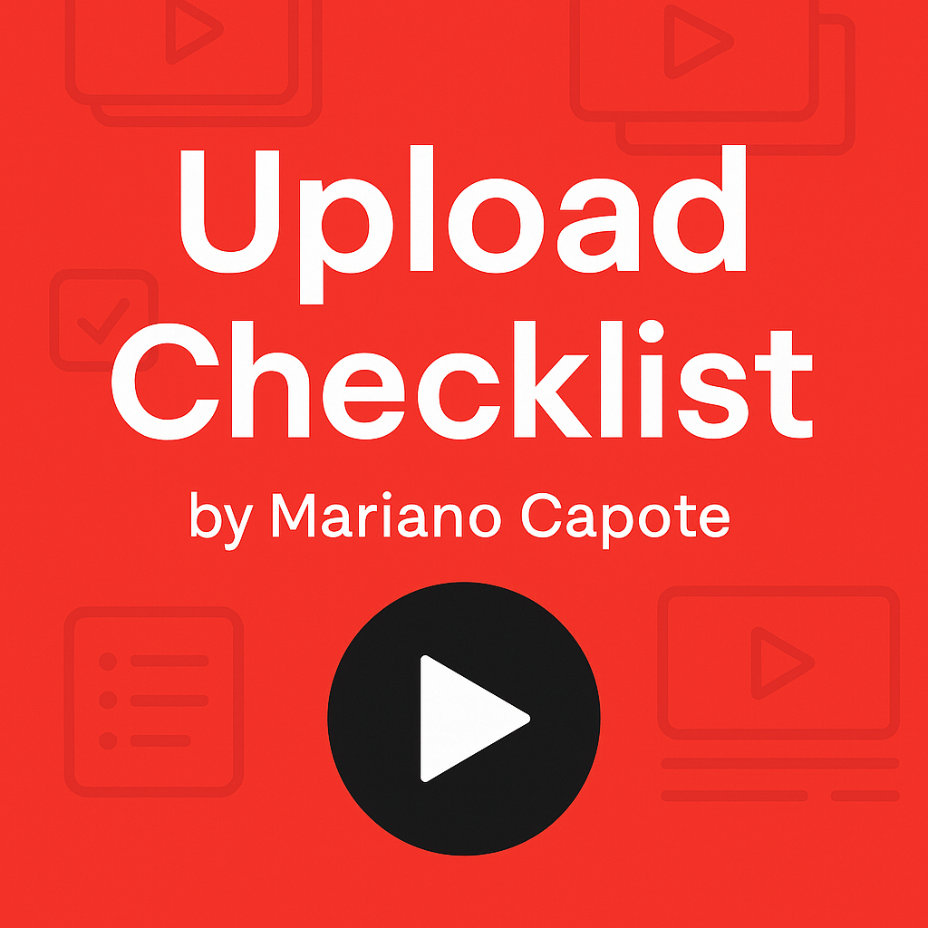YouTube Upload Checklist

☐ Is the video file uploaded in the correct format?
☐ Is the title clear, searchable, and under 60 characters?
☐ Have you written a compelling video description?
☐ Are relevant keywords and hashtags included?
☐ Is the custom thumbnail uploaded?
☐ Are end screens and cards added?
☐ Is the video added to the appropriate playlist(s)?
☐ Have you enabled monetization settings (if applicable)?
☐ Is the video scheduled or set to publish at the right time?
☐ Have you pinned a top comment?
☐ Have you shared the video on social media and to your email list?
☐ Have you replied to early comments within 24–48 hours?

